Name: Prathamesh Prakash Agawane(142203001)

Div: 2(Comp)-S5 Batch

Assignment-6

1)Simple Program

Input

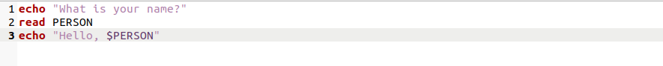

Output

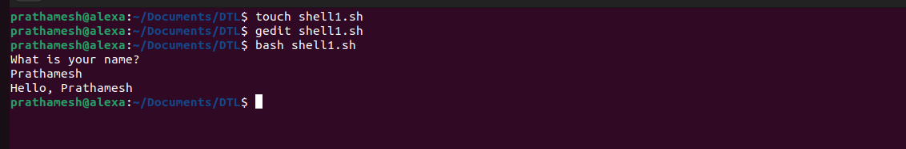

2)If statement

Input

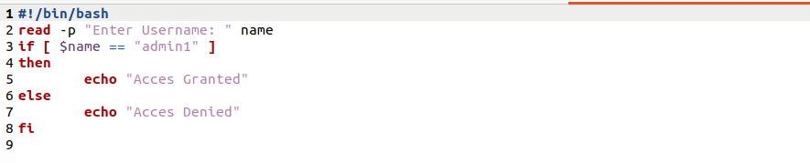

Output

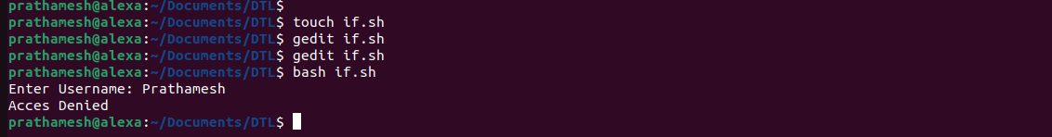

3)If else

Input

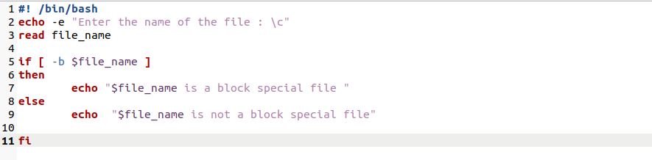

Output

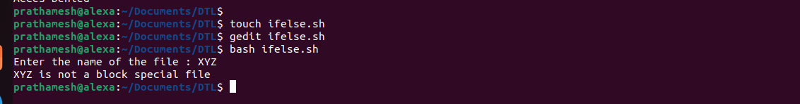

4) For Loop

Input

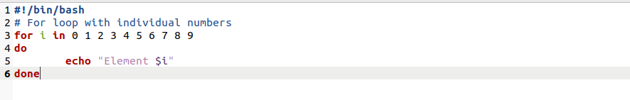

Output

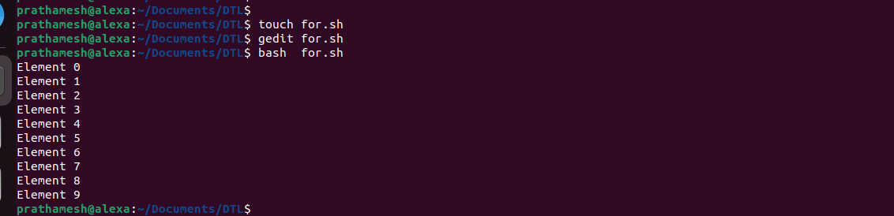

5) Nested For Loop

Input

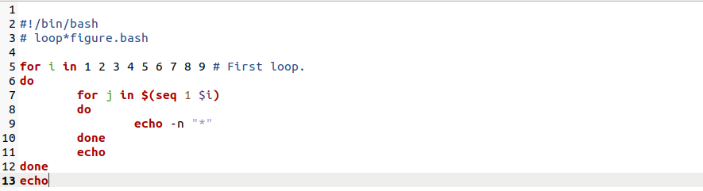

Output

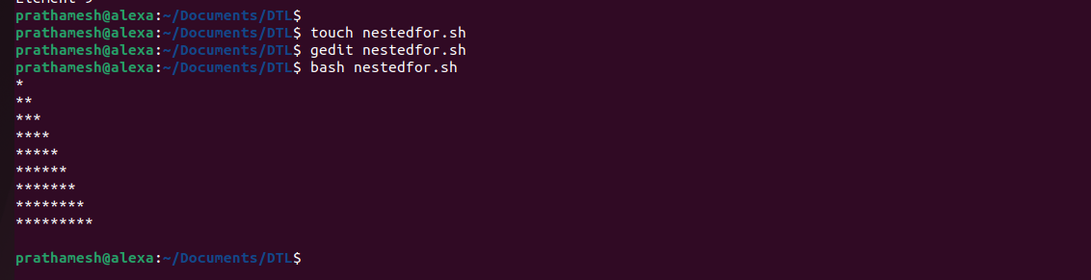

6)While

Input

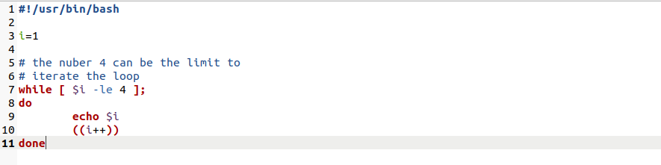

Output

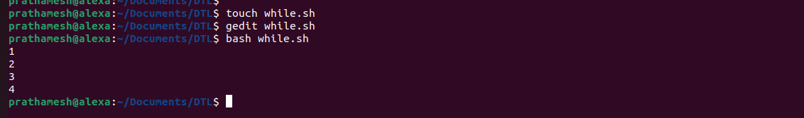

7)String length

Input

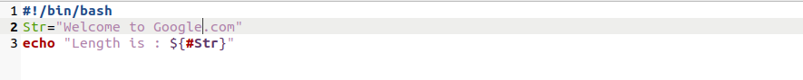

Output



8) Nested If else

Input

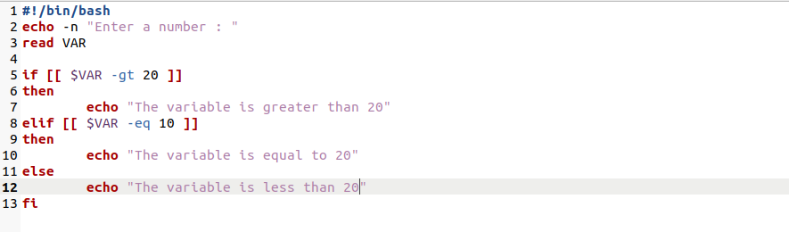

Output

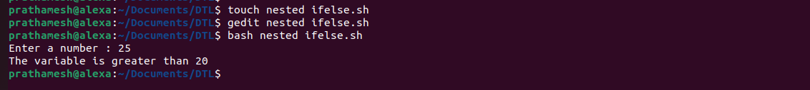

9)Cat String

Input

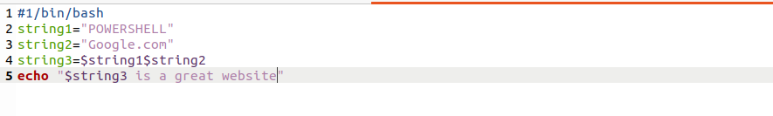

Output



10)String Path

Input

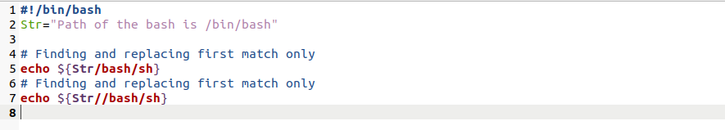

Output

